LAB 3

Dynamic Analysis & Test Design Techniques
Amantle Dikoloti
Student ID: 23017837 | Repository: taskmanagerepo | Target: app.tasks.calculate_discount(price, is_premium)

1. Test basis and scope
Published implementation: a premium status equal to True returns price × 0.8; other status values return the unchanged price. The project README provides no formal upper price limit and no prescribed error handling for invalid inputs. Existing unit tests confirm 100 → 80 (premium) and 100 → 100 (regular).
Test-design assumptions, not supplied specifications: valid prices are finite non-negative numbers and valid membership statuses are Boolean True and False. A hypothetical lower boundary of 0 is used for boundary-value design; invalid-input observations are not labelled confirmed specification defects.

2. Equivalence-partition table
Input | Class | Example | Validity / observed handling
price | Zero / lower boundary | 0 | Valid (assumed)
price | Positive integer | 25 | Valid (assumed)
price | Positive fractional | 49.99 | Valid (assumed)
price | Negative number | -0.01 | Invalid (assumed); negative result observed
price | Non-numeric string | "invalid-price" | Invalid (assumed); branch-dependent outcome
price | Missing value | None | Invalid (assumed); premium branch raises TypeError
is_premium | Boolean premium | True | Valid
is_premium | Boolean regular | False | Valid
is_premium | String / absent | "yes", None | Invalid (assumed); treated as regular
is_premium | Numeric rather than Boolean | 1 | Invalid (assumed); 1 == True selects premium

3. Boundary-value design
Boundary | Just below | At boundary | Just above | Interpretation
Assumed price minimum | -0.01 | 0 | 0.01 | Tested for True/False; -0.01 is an invalid-class probe
Membership | N/A | True / False | N/A | Discrete categories, not ordered numeric boundaries
Maximum price | Not specified | Not specified | Not specified | A large number is a stress case, not a boundary

4. Executable valid-input test design and observed results
The ten-case sets were executed using Pytest in the student repository. Test outcomes below are grounded in screenshots from the existing runs.
Set / ID | Price | Premium | Expected output | Result
AI A01 | 0 | True | 0 | PASS
AI A02 | 0 | False | 0 | PASS
AI A03 | 0.01 | True | 0.008 | PASS
AI A04 | 0.01 | False | 0.01 | PASS
AI A05 | 1 | True | 0.8 | PASS
AI A06 | 1 | False | 1 | PASS
AI A07 | 100 | True | 80 | PASS
AI A08 | 100 | False | 100 | PASS
AI A09 | 1e+06 | True | 800000 | PASS
AI A10 | 1e+06 | False | 1e+06 | PASS
Cmp C01 | 0 | True | 0 | PASS
Cmp C02 | 0 | False | 0 | PASS
Cmp C03 | 0.01 | True | 0.008 | PASS
Cmp C04 | 0.01 | False | 0.01 | PASS
Cmp C05 | 25 | True | 20 | PASS
Cmp C06 | 25 | False | 25 | PASS
Cmp C07 | 49.99 | True | 39.992 | PASS
Cmp C08 | 49.99 | False | 49.99 | PASS
Cmp C09 | 250 | True | 200 | PASS
Cmp C10 | 250 | False | 250 | PASS

Files: test_discount_cases.py (10 passed, 0 failed); test_discount_comparison.py (10 passed, 0 failed). pytest.approx was used to compare floating-point outputs.

5. Exploratory invalid-input and edge-case design
These eight added cases characterise current implementation behaviour. A test passing here means the code matches the observed result or exception; it does not mean the behaviour complies with an unstated input-validation requirement.
ID | Price | Premium | Observed expectation | Interpretation
I01 | -0.01 | True | -0.008 | Negative input accepted
I02 | -0.01 | False | -0.01 | Negative input unchanged
I03 | 100 | "yes" | 100 | Non-Boolean treated as regular
I04 | 100 | None | 100 | Missing status treated as regular
I05 | 100 | 1 | 80 | Numeric 1 matches True
I06 | "invalid-price" | False | "invalid-price" | Nonnumeric price propagated
I07 | "invalid-price" | True | TypeError | Nonnumeric price raises error
I08 | None | True | TypeError | Missing price raises error

Executable file: test_discount_invalid_cases.py. The 8 cases were locally checked against a faithful reproduction of the published calculate_discount function body (8 passed).

6. Reasoned test design and hand-worked calculations
The twelve cases below follow the stated domain assumptions. They include the assumed price boundary of zero, ordinary prices, both Boolean membership categories and invalid inputs.
ID | Price | Premium | Expected / observed | Reason for selection
M01 | -0.01 | True | -0.008 | Below assumed price minimum; observed behaviour
M02 | -0.01 | False | -0.01 | Below minimum; no premium discount
M03 | 0 | True | 0 | At lower boundary; premium
M04 | 0 | False | 0 | At lower boundary; regular
M05 | 0.01 | True | 0.008 | Just above lower boundary; premium
M06 | 0.01 | False | 0.01 | Just above boundary; regular
M07 | 25 | True | 20 | Ordinary positive integer; premium
M08 | 25 | False | 25 | Ordinary integer; regular
M09 | 49.99 | True | 39.992 | Positive fractional price; premium
M10 | 49.99 | False | 49.99 | Positive fractional price; regular
M11 | 100 | "yes" | 100 | Invalid membership type; observed regular branch
M12 | None | True | TypeError | Missing price; observed exception
The first six rows are the boundary-focused comparisons: the original test set included M03–M06, but not M01–M02. Thus 4/6 proposed boundary combinations (66.7%) were reproduced. Negative values are invalid-class probes, not a formally specified required rejection outcome.

7. AI comparison, omissions, and possible hallucinations
Measure | What the evidence supports
Overlap | The earlier two valid-input suites share 4 exact combinations. The 12-case reasoned draft shares the same four boundary combinations with Set A.
Near-zero boundary reproduction | For six reasoned boundary combinations (-0.01, 0, 0.01 × True/False), original Set A included four: 4/6 = 66.7%. The negative-price pair was absent.
Differences | Set A additionally samples 1, 100 and 1,000,000 for both valid statuses. The reasoned draft adds negative prices, 25, 49.99 and invalid input types.
Gaps in original sets | The original suite did not check negative prices, nonnumeric prices or non-Boolean status inputs; the reasoned and exploratory sets investigate these.
Unsupported / hallucinated boundaries | No formal maximum price or Boolean numeric threshold was supplied. The 1,000,000 case is a large-value test, not a justified upper boundary.
Methodological limitation | The 66.7% statistic is a reproducible overlap count.

8. Results and discussion
The two verified valid-input suites each passed 10/10 cases. Passing results indicate agreement for selected inputs, not full functional correctness. The exploratory probes show the function accepts negative values, treats the integer 1 as premium and handles nonnumeric prices differently across branches. The lack of a supplied error-handling specification prevents classifying all such observations as confirmed defects.
The reasoned table made the boundary analysis clearer. The tests covered zero and 0.01 for both premium and regular customers, but omitted both negative-price cases. That gives four overlapping boundary cases out of six (66.7%). The tests also used large prices, but a large price is not an upper boundary when no maximum was specified. The main lesson is that passing tests do not guarantee complete input coverage: invalid types and missing values need attention too. These are interpreted as potential validation gaps, not proven specification violations.

9. Execution evidence
The following captures are from the verified Pytest runs of the two original test suites.
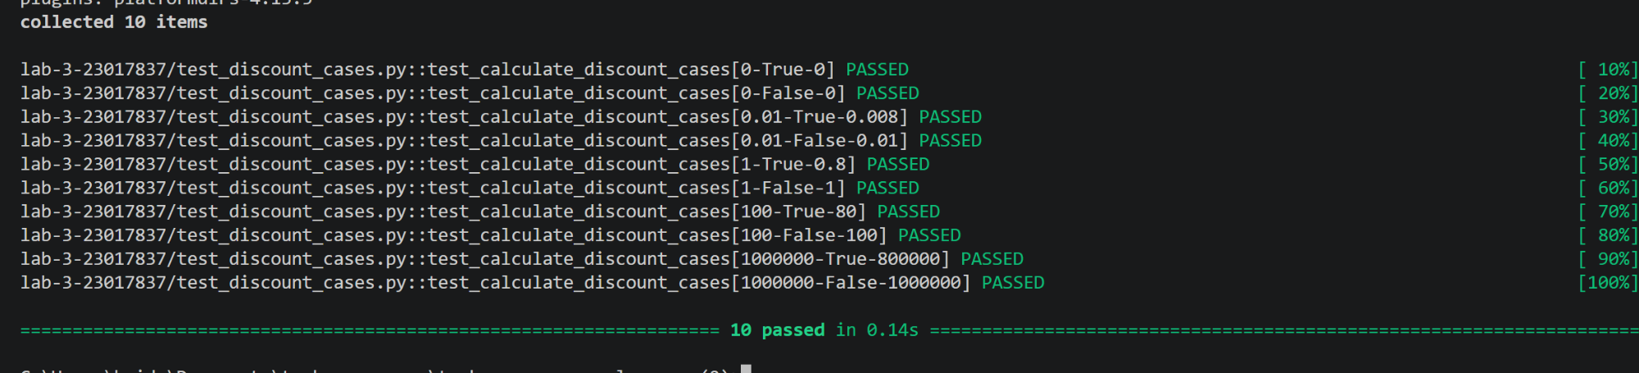
Figure 1. Original ten valid-input cases: all passed.
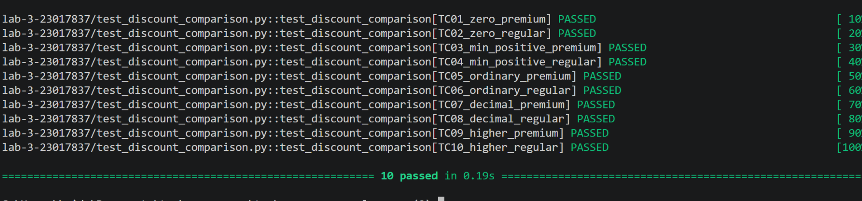
Figure 2. Comparison ten valid-input cases: all passed.

